Project Design Phase-II
Data Flow Diagram & User Stories
Date | 28.09.2026
Team ID | SWTID-2026-4440
Project Name | Auto Ticket Classification using FLOW DESIGNER
Maximum Marks | 4 Marks

Data Flow Diagrams:
A Data Flow Diagram (DFD) is a traditional visual representation of the information flows within a system. A neat and clear DFD depicts the system requirements graphically, demonstrating how ticket data enters the system, how Flow Designer triggers and processes classification rules, how dependent choice values are verified, and how the records are updated and assigned in the database.

DFD Level 0 (Context Level Diagram)
Level 0 DFD illustrates the overall boundary of the Auto Ticket Classification system, interacting with external entities (Caller / School User and IT Support Groups) and the core Ticket database.
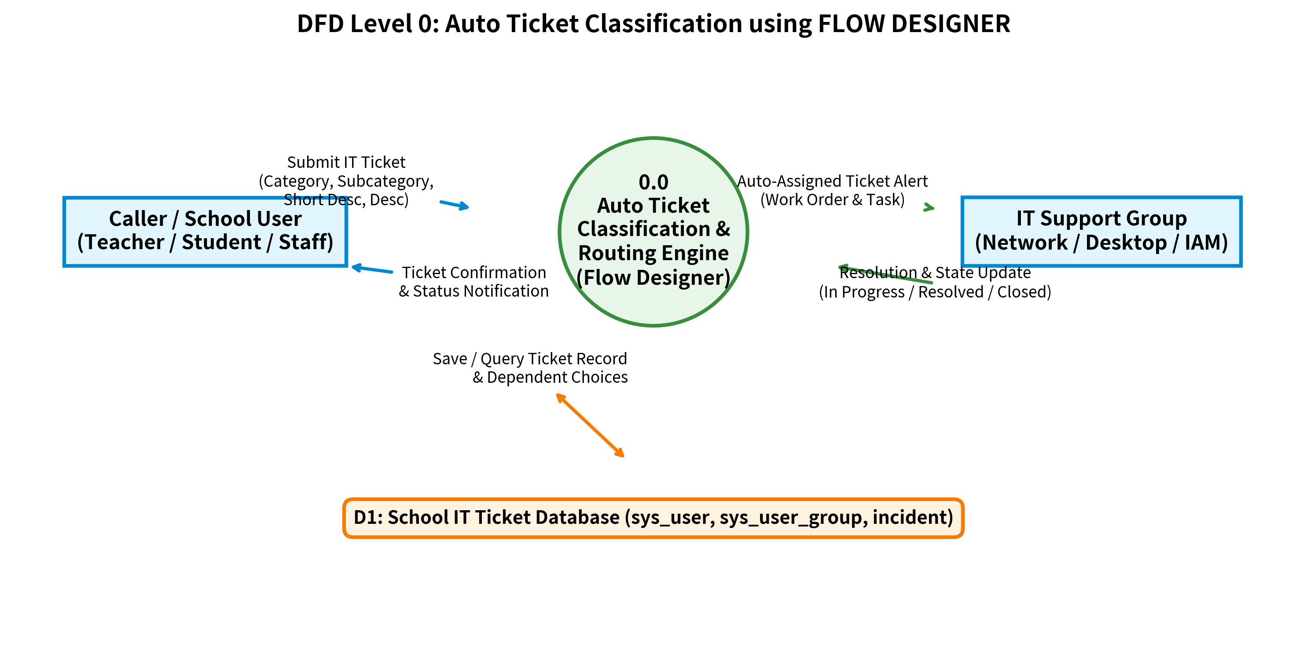
Figure 1: DFD Level 0: Context Diagram for Auto Ticket Classification Engine

DFD Level 1 (Decomposition Diagram)
Level 1 DFD decomposes the system into detailed sub-processes: Ticket Submission & Field Validation (1.0), Category & Subcategory Dependency Logic (2.0), Flow Designer Auto-Classification & Routing (3.0), and Notification & State Lifecycle Management (4.0).
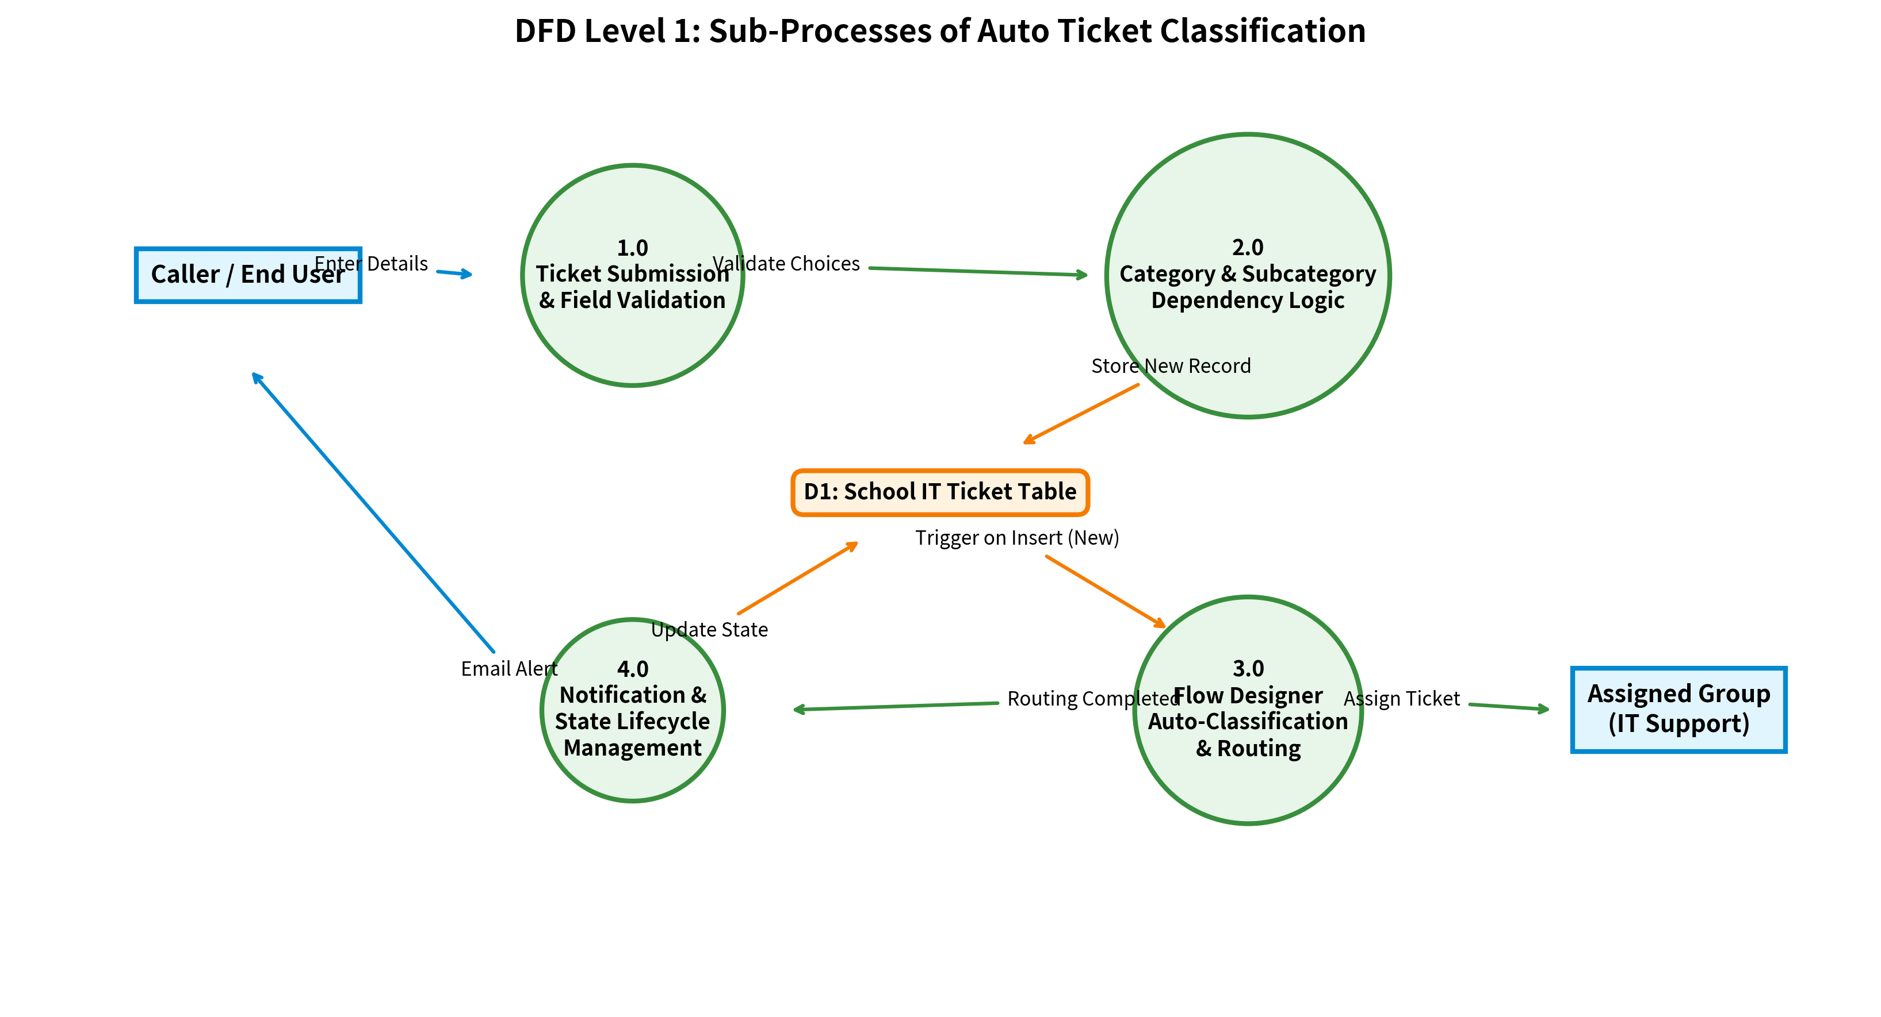
Figure 2: DFD Level 1: Sub-Processes & Data Stores for Automated Routing

Choice Field Configuration & Dependency Architecture
To ensure structured and consistent data capture, the School IT Ticket table contains dependent dropdown fields. The Subcategory choices are dynamically populated based on the selected Category choice values as shown below:
Category to Subcategory Mapping Rules:
- Network → Wi-Fi
- Hardware → Projector
- Access → Forgot password
- Performance → Slow computer

Dictionary Entry & Dependent Field Setup (Backend Design)
In the Dictionary Entry for Subcategory (`sys_choice`), the 'Use dependent field' checkbox is checked and mapped to the 'Category' field. Each choice value carries the corresponding dependent value (e.g., access, network, performance, hardware) as illustrated in the system screenshot:
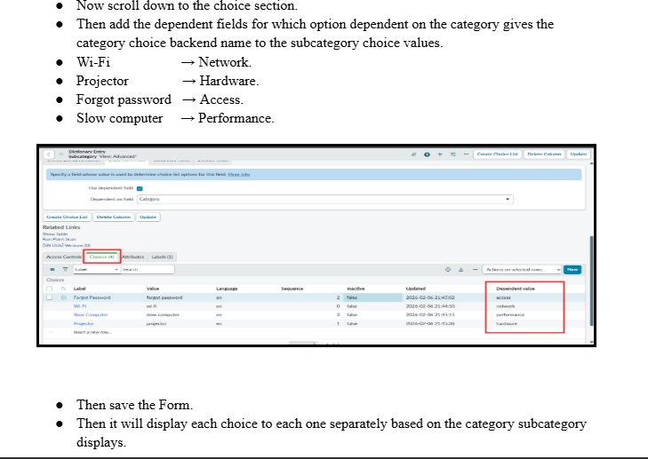
Figure 3: Dictionary Entry: Subcategory Choices with Dependent Values

Frontend Form Design & Dynamic Dropdown Verification
When a user selects a Category on the Ticket Form, the Subcategory dropdown immediately filters to display only the relevant sub-options:
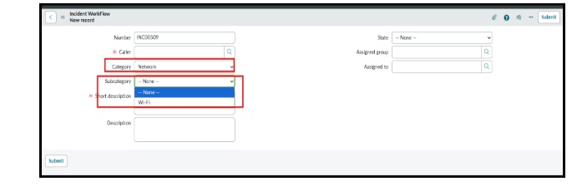
Figure 4: Ticket Form: Network Category showing dependent Wi-Fi Subcategory

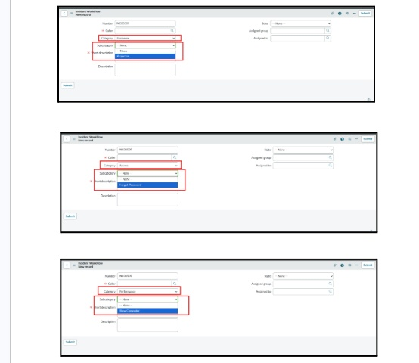
Figure 5: Ticket Form: Verification of Hardware, Access, and Performance Dependent Choices

User Stories
Use the below template to list all the user stories for the product.
User Type | Functional Requirement (Epic) | User Story Number | User Story / Task | Acceptance criteria | Priority | Release
Caller (School Staff / Student) | Ticket Submission & Fields | USN-1 | As a Caller, I want to submit a ticket with Number, Caller, Short Description, and Description so that IT support is aware of my issue. | All mandatory fields are captured and a unique ticket number is generated. | High | Sprint-1
Caller (School Staff / Student) | Dependent Choices Setup | USN-2 | As a Caller, I want Subcategory choices (Wi-Fi, Projector, Forgot password, Slow computer) to filter automatically based on Category (Network, Hardware, Access, Performance). | Subcategory dropdown displays only options dependent on selected Category. | High | Sprint-1
System (Flow Designer) | Auto Classification & Routing | USN-3 | As an automated Flow Designer, I want to trigger when a new ticket is submitted and classify it into the correct Support Group based on Category/Subcategory. | Tickets with Network/Wi-Fi route to Network Group; Hardware/Projector route to Desktop Support; Access to IAM; Performance to Systems Team. | High | Sprint-1
IT Support Technician | Assignment & State Management | USN-4 | As an IT Support Technician, I want tickets assigned to my group with State set to 'In progress' so that I can immediately start resolution. | Assigned Group field is auto-populated and State transitions from 'New' to 'In progress'. | High | Sprint-1
Caller (School Staff / Student) | Automated Notifications | USN-5 | As a Caller, I want to receive email notifications when my ticket is created, assigned, and updated. | Automated emails are sent with ticket number, category, and assigned technician details. | Medium | Sprint-1
IT Support Technician | Resolution & Closure | USN-6 | As an IT Support Technician, I want to update the ticket state to 'Resolved' or 'Closed' with resolution notes upon fixing the issue. | Ticket state updates properly and caller is notified of resolution. | High | Sprint-2
IT Administrator | Workflow Monitoring & Analytics | USN-7 | As an IT Administrator, I want to view Flow Designer execution logs and classification metrics to ensure optimal routing performance. | Execution history and routing success rates are viewable in Flow Designer dashboard. | Medium | Sprint-2

